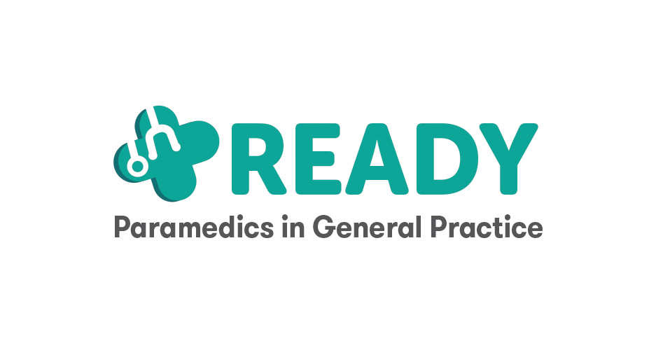

About this leaflet

Findings from the study indicated that patients would like to have information provided by their GP surgery about the paramedic role. Patients would like to know about how paramedics are qualified to deliver their care. Patients also would like information about how paramedics work with other members of the practice team and about how they are supervised.
The study found that there is significant variation between practices in terms of the care provided by paramedics. There is also variation in the skills and qualifications of paramedics. Some practices employ more than one paramedic. Sometimes different paramedics working for the same practice may have a different role and patients would like to understand this. what paramedics do in terms of providing care, and their skills and qualifications, varies significantly between practices.
We have provided some template text for a patient information leaflet. This should be adapted by a member of the team with a clear understanding of the paramedic(s) role and scope. The information should then be agreed with the paramedic(s) before being shared with patients. Patients have highlighted the importance of providing this printed information using accessible font typefaces of an appropriate size (e.g. minimum 12 point), and of considering providing information in other formats (and, where applicable, languages).

Content for leaflet
<GP Surgery name>

Understanding the role of a paramedic
<delete as applicable and/or add additional tasks>

Who are paramedics?
Paramedics are qualified and regulated healthcare professionals who provide generalist medical care. All paramedics are registered with the Health and Care Professions Council. Although the majority of paramedics work in the ambulance service, a growing number of paramedics are now working in GP surgeries. These paramedics can form an important part of the team that deliver services at your surgery and help ensure you receive the right care when you need it.

What do paramedics do?

Patient assessments
- Conduct assessments of patients: by phone, in clinic and online.
- Take medical histories and perform physical examinations.
- Carry out home visits for patients.
- Identify urgent medical issues and prioritise care.

Treatment and care
- Provide treatments including wound care.
- Administer medications.
- Offer advice on managing minor illnesses and injuries.
- Support patients with long-term health conditions.
- Some paramedics will have additional skills and will manage chronic conditions.
- Prescribe medications if needed as part of the patient’s care
- Request tests and make referrals to other healthcare professionals and services

Health education

- Educate patients on healthy lifestyle choices.
- Provide information on disease prevention and management.
- Support patients in understanding their treatment plans.

Collaboration with healthcare team

- Work closely with GPs, nurses, and other healthcare professionals.
- Participate in practice team meetings.
- Help the service to provide seamless care and follow-up for patients.

UNDERSTANDING PARAMEDIC QUALIFICATIONS
<delete as applicable/adapt to make specific to paramedic(s)>

Education
Paramedics typically hold a degree in Paramedic Science. Some paramedics who qualified before 2018, may have a ‘Certificate of Higher Education’ rather than a degree but are still registered as paramedics with the Health and Care Professions Council.

Further qualifications
Some paramedics hold additional qualifications to become either a First Contact Practitioner (FCP) or an Advanced Clinical Practitioner (ACP). Paramedics who are ACPs can take on additional duties and may have a lead role in the delivery of some specialist care (e.g. diabetes or learning difficulties)

Training
Extensive training in emergency medical care, including advanced life support, trauma management and patient assessment. Some paramedics complete additional training that is specific to general practice such as a Diploma in Primary and Urgent Care.

Prescribing
Some paramedics may have completed a prescribing qualification meaning they can prescribe any medicine for any medical condition, within their level of professional competence. Paramedics without a prescribing qualification work by communicating with GPs to ensure patients receive the correct medication in a timely manner.

Supervision
- Paramedics have different levels of qualifications and experience. This means that the activities they perform are agreed on an individual basis with each GP surgery.
- Paramedics can refer to other members of the team (including a GP) where necessary.
- Paramedics have access to a named GP [supervisor] who is available to provide support and advice when needed, and who supports their overall professional practice.

